Smart PID telegram bot – Release Notes

How to Install

1. Install Java 8 or above
   1. For ubuntu use following command
   2. sudo apt update
   3. sudo apt install openjdk-8-jdk
2. Copy SmartPID-1.0-SNAPSHOT-jar-with-dependencies.jar into directory.
3. Copy botConfig.xml and logging.properties files to the same folder.
4. Setting up the service for auto start
   1. Use file telegrambot.service file provided.
   2. Inside the file change Working directory to where bot is located
   3. 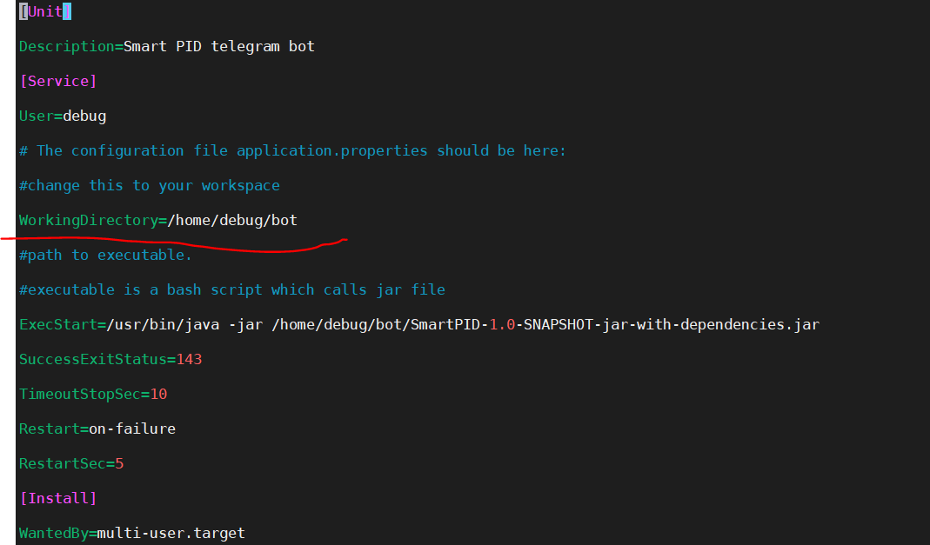
   4. Copy the file to /etc/systemd/system/
   5. Use following commands to enable the service first time
      1. sudo systemctl daemon-reload
      2. sudo systemctl enable telegrambot.service
      3. sudo systemctl start telegrambot
      4. sudo systemctl status telegrambot
      5. sudo systemctl stop telegrambot – For Stopping the bot
      6. View Log using
         1. sudo journalctl -e -u telegrambot.service

How to configure database/MQTT servers.

1. You must use botConfig.xml file for that. Structure is like this
2. Key is the property you need to change. You change the value accordingly.
   1. <entry key="MQTT_HOST">tcp://localhost:1883</entry>
   2. <entry key="MQTT_USER">debug</entry>
   3. <entry key="MQTT_PASSWORD">anusha</entry>
   4. <entry key="BOT_TOKEN">1112218327:AAGhJpMvAVObx-9VNNm5uvMq0iu4tKby-Wc</entry>
   5. <entry key="BOT_USERNAME">Smart PID Bot</entry>
   6. <entry key="DB_HOST">localhost</entry>
   7. <entry key="DB_PORT">3306</entry>
   8. <entry key="DB_USER">TELEGRAM</entry>
   9. <entry key="DB_PASSWORD">et7bpAKIh11bWy4m$</entry>
   10. <entry key="DB_NAME">ARZAMAN_DB</entry>
3. Keep this file safe.

How to use the bot

1. Commands List
   1. Use /help to list down all available command list
   2. Use /start to get started